Project Design Phase-II
Technology Stack (Architecture & Stack)

Date | 10 July 2026
Team ID
Project Name | BOOK-STORE (BookVerse)
Maximum Marks | 4 Marks

Technical Architecture:
The BookVerse platform utilizes a highly scalable, decoupled MERN stack architecture.
- Frontend (Client): A Next.js/React application deployed on Netlify, serving the UI to users via a global CDN.
- Backend (API): An Express.js RESTful API running on Node.js, hosted on a cloud platform (e.g., Vercel, Render, or Heroku), processing business logic and authentication.
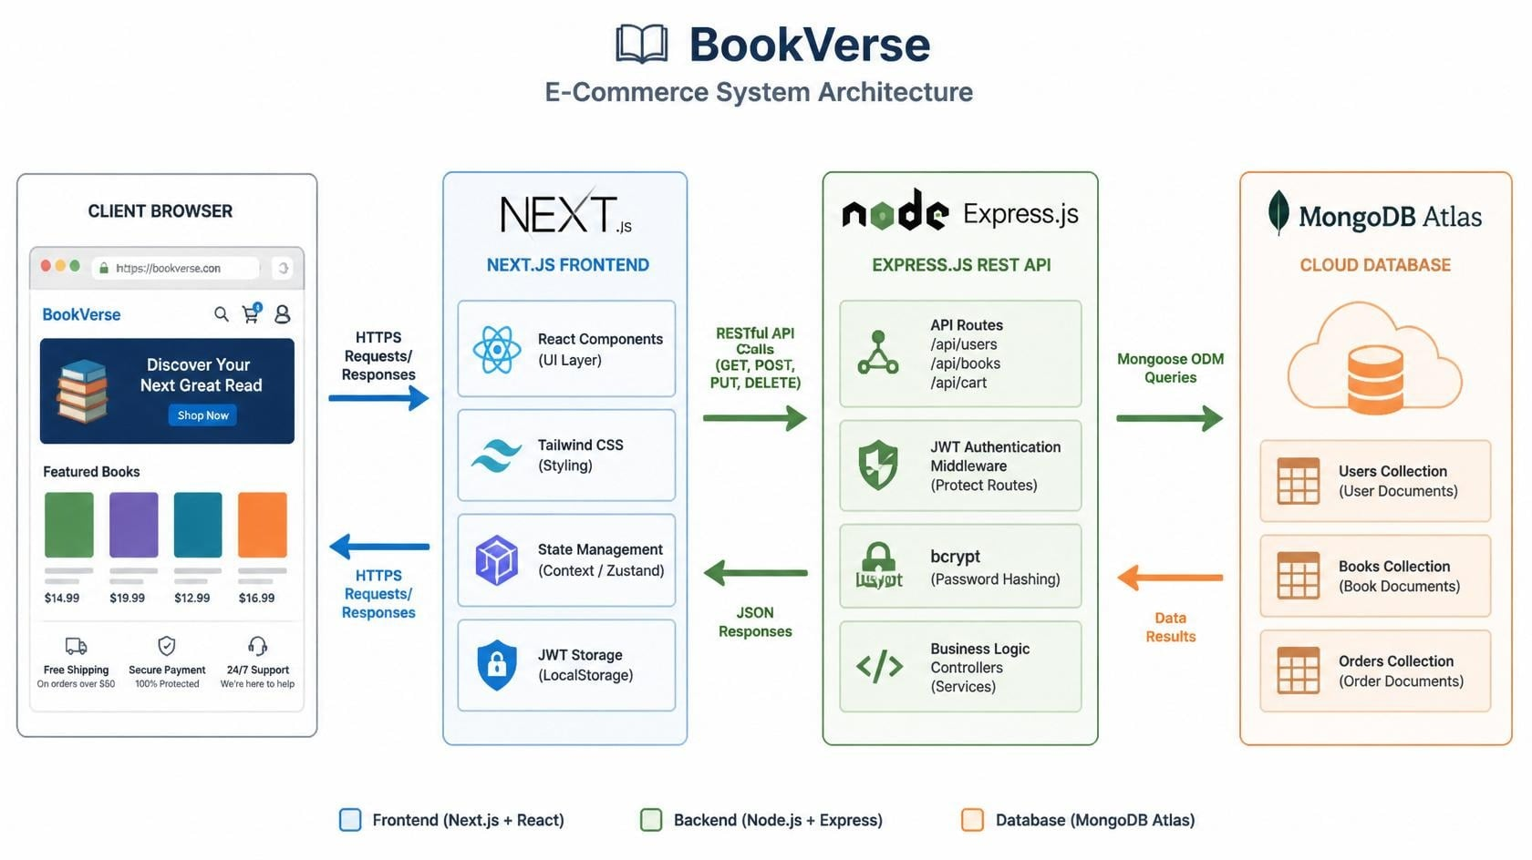
- Database: A cloud-hosted MongoDB Atlas cluster securely storing user data, book inventory, and order records.

Table-1 : Components & Technologies:
S.No | Component | Description | Technology
 | User Interface | Responsive Web UI for browsing books, managing the cart, and the admin dashboard. | Next.js, React.js, TypeScript, Tailwind CSS
 | Application Logic-1 | Backend API routing, business logic, and request processing. | Node.js, Express.js
 | Application Logic-2 | Secure user authentication and session management. | JSON Web Tokens (JWT), bcrypt
 | Application Logic-3 | Object Data Modeling (ODM) to enforce database schemas. | Mongoose
 | Database | Core database for storing users, book inventory, and orders (NoSQL format). | MongoDB
 | Cloud Database | Fully managed database service on the cloud providing high availability and backups. | MongoDB Atlas
 | File Storage | Storage for static assets, such as book cover images uploaded by the admin. | Cloudinary / AWS S3 (or Local Filesystem for MVP)
 | External API-1 | Secure payment processing for user checkout. | Stripe API / Razorpay API
 | External API-2 | Email delivery for user registration confirmation and order receipts. | SendGrid / Nodemailer
 | Infrastructure (Server / Cloud) | Application Deployment: Frontend on Edge Network CDN, Backend on Cloud Server. | Netlify (Frontend), Vercel/Render (Backend API)

Table-2: Application Characteristics:
S.No | Characteristics | Description | Technology
1 | Open-Source Frameworks | The application is built entirely on robust open-source libraries and frameworks. | React.js, Next.js, Node.js, Express.js, Tailwind CSS, Mongoose
2 | Security Implementations | Passwords are cryptographically hashed before storage. Routes are protected via token-based authorization. Cross-Origin Resource Sharing (CORS) is configured to prevent unauthorized API access. | bcrypt (password hashing), JWT (Auth), dotenv (environment variables), CORS middleware
3 | Scalable Architecture | The architecture is heavily decoupled. The Next.js frontend and Express backend scale independently. The NoSQL database allows for horizontal scaling as the book catalog grows. | RESTful API Architecture, Microservices-ready structure, MongoDB (NoSQL)
4 | Availability | The frontend is distributed globally via Edge CDN, ensuring high uptime. The database utilizes managed clusters with built-in replication. | Netlify CDN, MongoDB Atlas Replica Sets
5 | Performance | The frontend leverages pre-rendering strategies to deliver ultra-fast page loads. State management ensures cart updates don't require full page reloads. | Next.js Server-Side Rendering (SSR) & Static Site Generation (SSG), React Context API

